1. **Import the dataset and do usual exploratory analysis steps like checking the structure & characteristics of the dataset**
   1. ***Data type of columns in a table.***

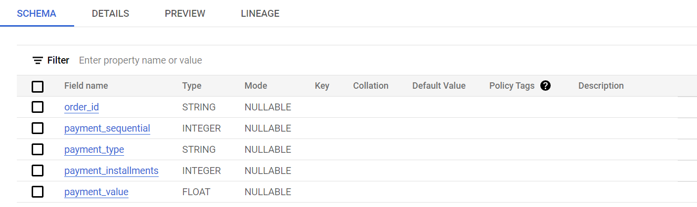

* 1. ***Time period for which the data is given.***

*\*\*\*\*\*\*\*\*\*\*\*\*\*\*\*\*\*\*\*\*\*\*\*\*\*\*\*\*\*\*\*\*\*\*\*\*\*\*\*\*\*\*\*\*\*\*\*\*\*\*\*\*\*\*\*\*\*\*\*\*\*\*\*\*\*\*\*\*\*\*\*\*\**

SELECT

order_id,

order_purchase_timestamp,

EXTRACT (YEAR FROM order_purchase_timestamp) as YEAR,

EXTRACT (QUARTER FROM order_purchase_timestamp) as QUARTER,

EXTRACT(MONTH FROM order_purchase_timestamp) as MONTH

FROM `Assignment.orders_dataset`

ORDER BY order_purchase_timestamp

LIMIT 10

*\*\*\*\*\*\*\*\*\*\*\*\*\*\*\*\*\*\*\*\*\*\*\*\*\*\*\*\*\*\*\*\*\*\*\*\*\*\*\*\*\*\*\*\*\*\*\*\*\*\*\*\*\*\*\*\*\*\*\*\*\*\*\*\*\*\*\*\*\*\*\*\*\**

**Insights : -**

YEAR WISE data from 2016 -2018.

QUARTER WISE – 3rd Quarter in 2016 – 4th Quarter in 2018

Month Wise – Sep 2016 to Oct 2018

*\*\*\*\*\*\*\*\*\*\*\*\*\*\*\*\*\*\*\*\*\*\*\*\*\*\*\*\*\*\*\*\*\*\*\*\*\*\*\*\*\*\*\*\*\*\*\*\*\*\*\*\*\*\*\*\*\*\*\*\*\*\*\*\*\*\*\*\*\*\*\*\**

*Query result screen shot : -*

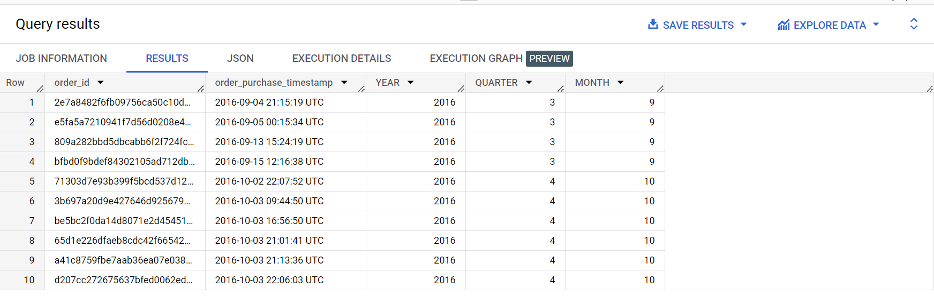

* 1. **Cities and States of customers ordered during the given period.**

***\*\*\*\*\*\*\*\*\*\*\*\*\*\*\*\*\*\*\*\*\*\*\*\*\*\*\*\*\*\*\*\*\*\*\*\*\*\*\*\*\*\*\*\*\*\*\*\*\*\*\*\*\*\*\*\*\*\*\*\*\*\*\*\*\*\*\*\*\****

SELECT

 c.customer_id,

 order_id,

 c.customer_city,

 c.customer_state

FROM `Assignment.customers_dataset` c

JOIN `Assignment.orders_dataset` as o

ON c.customer_id = o.customer_id

WHERE EXTRACT(YEAR FROM order_purchase_timestamp) BETWEEN 2016 and 2018

ORDER BY c.customer_id

LIMIT 10

***\*\*\*\*\*\*\*\*\*\*\*\*\*\*\*\*\*\*\*\*\*\*\*\*\*\*\*\*\*\*\*\*\*\*\*\*\*\*\*\*\*\*\*\*\*\*\*\*\*\*\*\*\*\*\*\*\*\*\*\*\*\*\*\*\*\*\*\*\*\*\****

**Insights :-**

*Incorrect city names have resulted in different rows if data is grouped by city.*

*\*\*\*\*\*\*\*\*\*\*\*\*\*\*\*\*\*\*\*\*\*\*\*\*\*\*\*\*\*\*\*\*\*\*\*\*\*\*\*\*\*\*\*\*\*\*\*\*\*\*\*\*\*\*\*\*\*\*\*\*\*\*\*\*\*\*\*\*\*\*\*\*\*\*\*\*\*\*\*\*\*\*\**

**Query result screenshot : -**

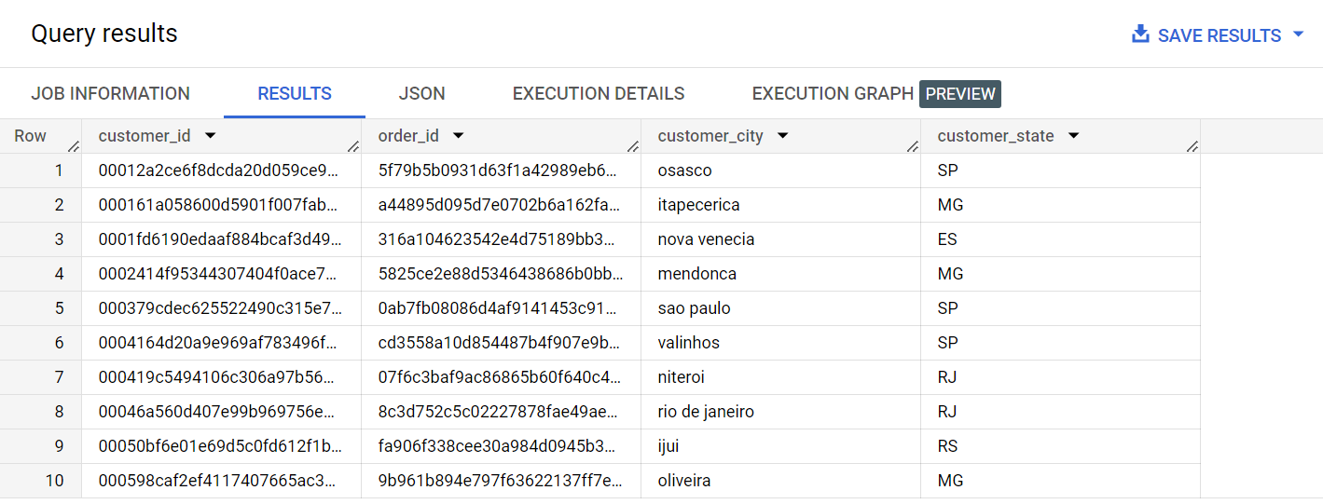

1. **In-depth Exploration:**
   1. Is there a growing trend on e-commerce in Brazil? How can we describe a complete scenario? Can we see some seasonality with peaks at specific months?

*\*\*\*\*\*\*\*\*\*\*\*\*\*\*\*\*\*\*\*\*\*\*\*\*\*\*\*\*\*\*\*\*\*\*\*\*\*\*\*\*\*\*\*\*\*\*\*\*\*\*\*\*\*\*\*\*\*\*\*\*\*\*\*\*\*\*\*\*\*\*\*\*\*\*\*\*\*\*\*\**

SELECT

 ROUND(SUM(p.payment_value),2) AS total_sum,

 EXTRACT(YEAR FROM order_purchase_timestamp) as Years

FROM `Assignment.orders_dataset` as o

JOIN `Assignment.payments_dataset` as p

ON o.order_id = p.order_id

GROUP BY Years

ORDER BY total_sum ASC

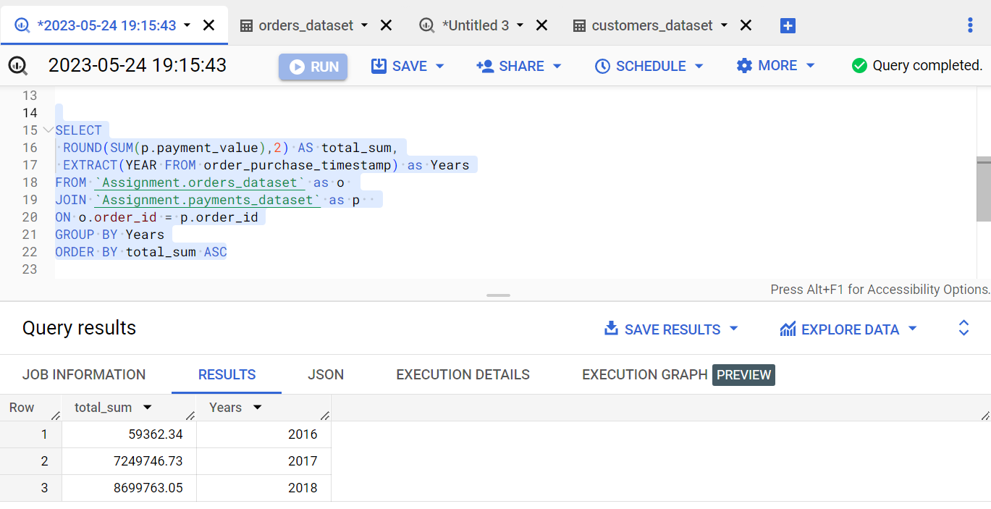

SELECT

 COUNT( DISTINCT c.customer_id) AS total_num_of_customers_per_year,

 EXTRACT(YEAR FROM order_purchase_timestamp) as Years

FROM `Assignment.orders_dataset` as o

JOIN `Assignment.customers_dataset` as c

ON o.customer_id = c.customer_id

GROUP BY Years

ORDER BY total_num_of_customers_per_year ASC

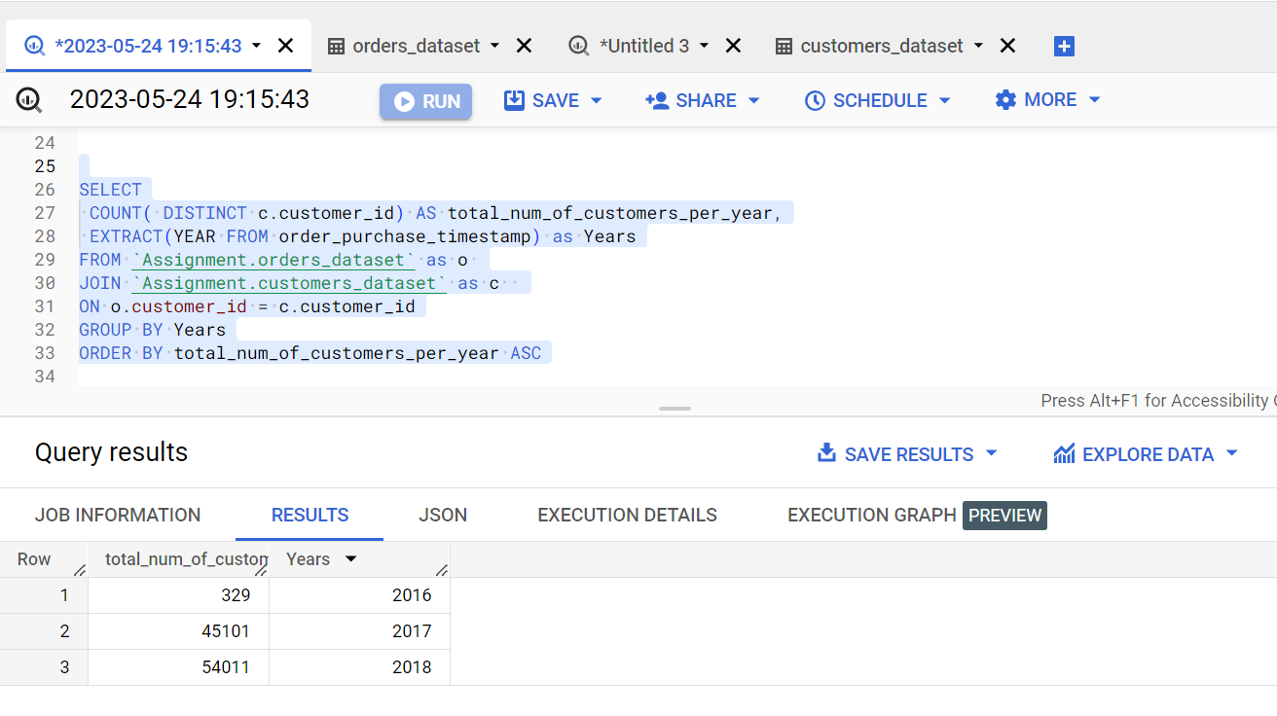

**Insights :-**

*There is a definite increase in e commerce over the duration on which data is processed. We can see an increase in total number of customers per year as well as increase in total sum of payments per year.*

*\*\*\*\*\*\*\*\*\*\*\*\*\*\*\*\*\*\*\*\*\*\*\*\*\*\*\*\*\*\*\*\*\*\*\*\*\*\*\*\*\*\*\*\*\*\*\*\*\*\*\*\*\*\*\*\*\*\*\*\*\*\*\*\*\*\*\*\*\*\*\*\*\*\*\*\*\*\*\*\*\*\**

SELECT

 EXTRACT(YEAR from order_purchase_timestamp) as YEAR,

 EXTRACT(MONTH from order_purchase_timestamp) as MONTH,

 COUNT(order_id) as num_of_orders

FROM `Assignment.orders_dataset` as o

GROUP BY YEAR, MONTH

ORDER BY YEAR, MONTH

LIMIT 10

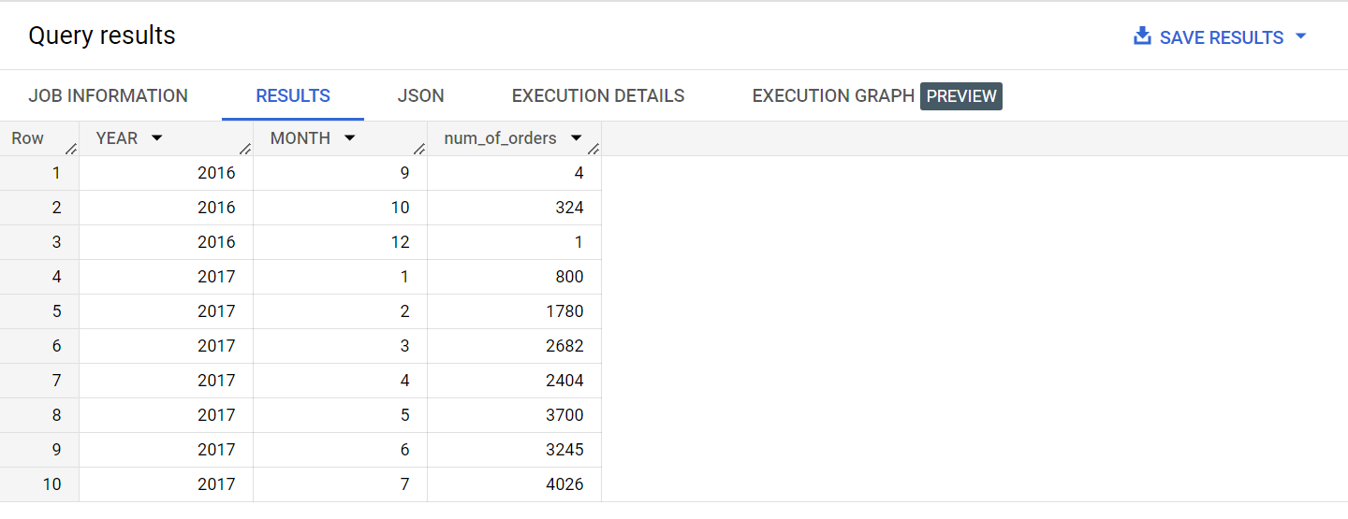

**Insights :-**

*With the growth of e commerce in Brazil from 2016 to 2018 more users start to place orders. Hence we see an increase in number of orders each year with the month of Nov 2017 hitting the peak in terms of total orders placed.*

*Max orders each year are placed during the 3nd and 4th Quarter i.e Between the Jul- Dec*

*\*\*\*\*\*\*\*\*\*\*\*\*\*\*\*\*\*\*\*\*\*\*\*\*\*\*\*\*\*\*\*\*\*\*\*\*\*\*\*\*\*\*\*\*\*\*\*\*\*\*\*\*\*\*\*\*\*\*\*\*\*\*\*\*\*\*\*\*\*\*\*\*\*\*\*\*\*\*\*\*\*\*\*\*\**

* 1. What time do Brazilian customers tend to buy (Dawn, Morning, Afternoon or Night)?

SELECT

 COUNT(d.order_id) as num_orders,

 d.Part_of_day

FROM

(

SELECT

 order_id,

 order_purchase_timestamp,

 CASE

    WHEN EXTRACT(TIME FROM order_purchase_timestamp) BETWEEN "05:00:00" AND "05:30:00"

    THEN "Dawn"

    WHEN EXTRACT(TIME FROM order_purchase_timestamp) BETWEEN "06:00:00" AND "11:59:59"

    THEN "Morning"

    WHEN EXTRACT(TIME FROM order_purchase_timestamp) BETWEEN "1:00:00" AND "16:59:59"

    THEN "Afternoon"

    WHEN EXTRACT(TIME FROM order_purchase_timestamp) BETWEEN "1:00:00" AND "18:59:59"

    THEN "Evening"

    ELSE "Night"

 END AS Part_of_day

FROM `Assignment.orders_dataset`

ORDER BY order_purchase_timestamp

) as d

GROUP BY d.Part_of_day

ORDER BY num_orders

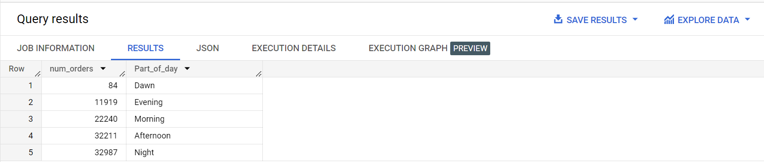

**Insights : -**

Max customers tend to buy during afternoon and night.

1. ***Evolution of E-commerce orders in the Brazil region:***
   1. Get month on month orders by states.

**Month on month data comparison among all states.**

SELECT

EXTRACT(MONTH from order_purchase_timestamp) as MONTH,

c.customer_state as States,

COUNT(order_id) as num_of_orders

FROM `Assignment.orders_dataset` as o

JOIN `Assignment.customers_dataset` as c

ON c.customer_id = o.customer_id

GROUP BY States, MONTH

ORDER BY MONTH,num_of_orders DESC

LIMIT 10

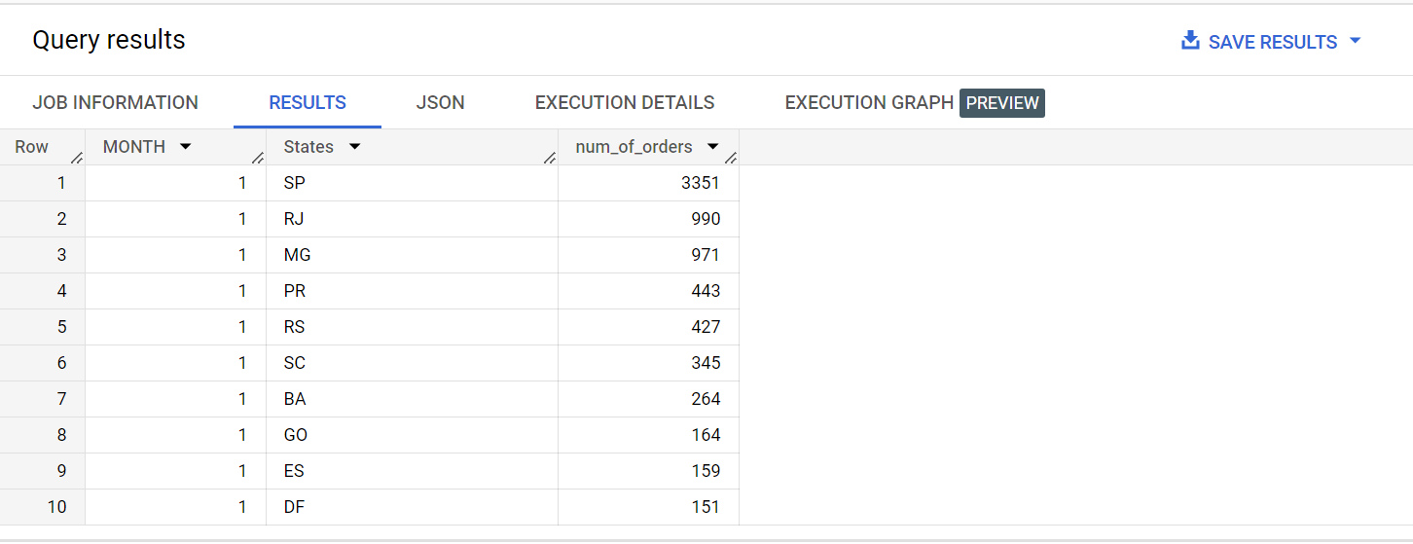

***States : SP, RJ and MG lead in total number of orders per month for each month when data checked over total duration available.***

**Month on month data comparison for each state separately.**

SELECT*,

 LAG(d.num_of_orders,1) OVER (PARTITION BY d.States ORDER BY d.MONTH) as prev_month_order,

 LEAD(d.num_of_orders,1) OVER (PARTITION BY d.States ORDER BY d.MONTH) as next_month_order

FROM

(

SELECT DISTINCT

c.customer_state as States,

EXTRACT(MONTH from order_purchase_timestamp) as MONTH,

COUNT(order_id) as num_of_orders,

FROM `Assignment.orders_dataset` as o

JOIN `Assignment.customers_dataset` as c

ON c.customer_id = o.customer_id

GROUP BY States, MONTH

) as d

ORDER BY d.States, d.MONTH

LIMIT 10

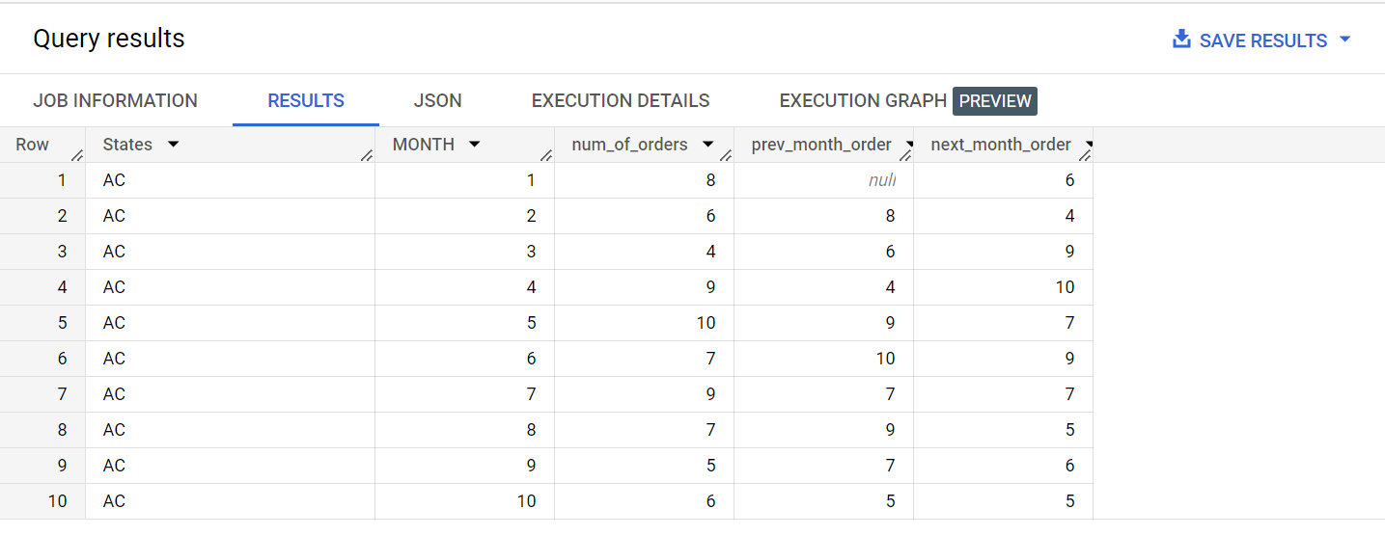

* 1. **Distribution of customers across the states in Brazil.**

SELECT

 COUNT(DISTINCT customer_id) as num_of_customers_per_state,

 customer_state

FROM `Assignment.customers_dataset`

GROUP BY customer_state

ORDER BY num_of_customers_per_state DESC

LIMIT 10

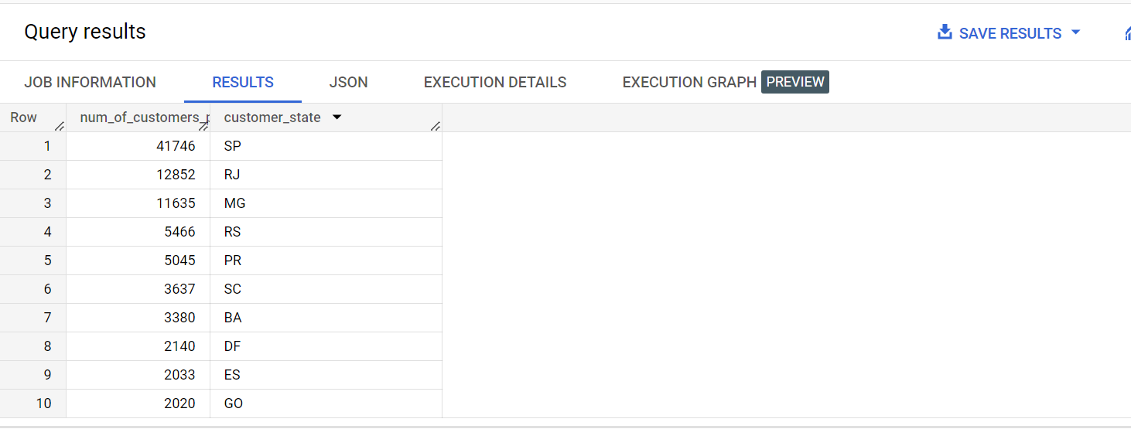

1. ***Impact on Economy: Analyze the money movement by e-commerce by looking at order prices, freight and others.***
   1. **Get % increase in cost of orders from 2017 to 2018 (include months between Jan to Aug only) - You can use “payment_value” column in payments table**

SELECT *,

 ROUND(((e.total_payments - e.previous_year_cost)/e.total_payments) * 100 ,2) as cost_inc_precentage

FROM

(

SELECT *,

 LAG(d.total_payments,1) OVER (ORDER BY d.Year) as previous_year_cost

FROM

(

SELECT

 EXTRACT(YEAR from order_purchase_timestamp) as Year,

 SUM(payment_value) as total_payments

FROM `Assignment.orders_dataset` as o

JOIN `Assignment.payments_dataset` as p

ON o.order_id = p.order_id

WHERE EXTRACT(YEAR from order_purchase_timestamp) IN(2017,2018) AND

EXTRACT(MONTH from order_purchase_timestamp) BETWEEN 1 AND 8

GROUP BY Year

ORDER BY Year

) as d

) as e

ORDER BY e.Year

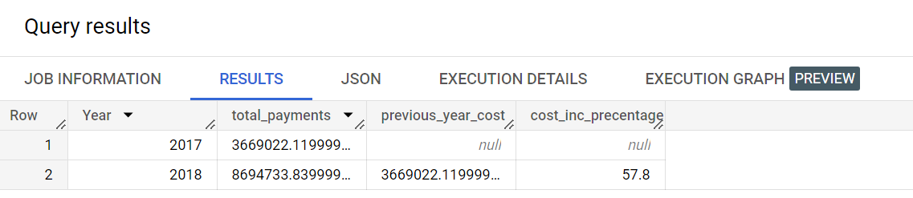

* 1. **Mean & Sum of price and freight value by customer state**

SELECT

  c.customer_state,

  SUM(oi.price) as sum_price,

  AVG(oi.price) as mean_price,

  SUM(oi.freight_value) as freight_value_per_state

FROM `Assignment.order_items_dataset` as oi

JOIN `Assignment.orders_dataset` as o

ON oi.order_id = o.order_id

JOIN `Assignment.customers_dataset` as c

ON o.customer_id = c.customer_id

GROUP BY c.customer_state

ORDER BY c.customer_state

LIMIT 10

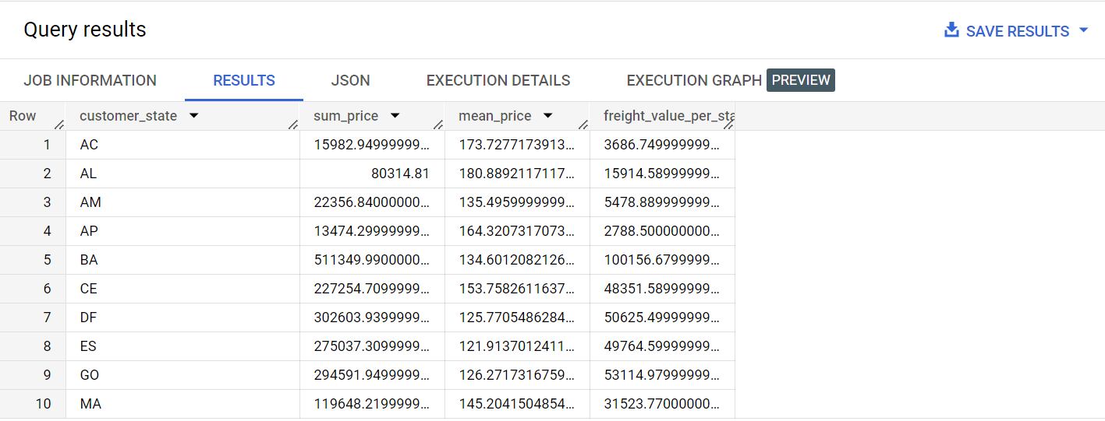

***5. Analysis on sales, freight and delivery time***

SELECT

 order_status,

 COUNT(order_id) as num_of_orders

FROM `Assignment.orders_dataset`

GROUP BY order_status

ORDER BY order_status

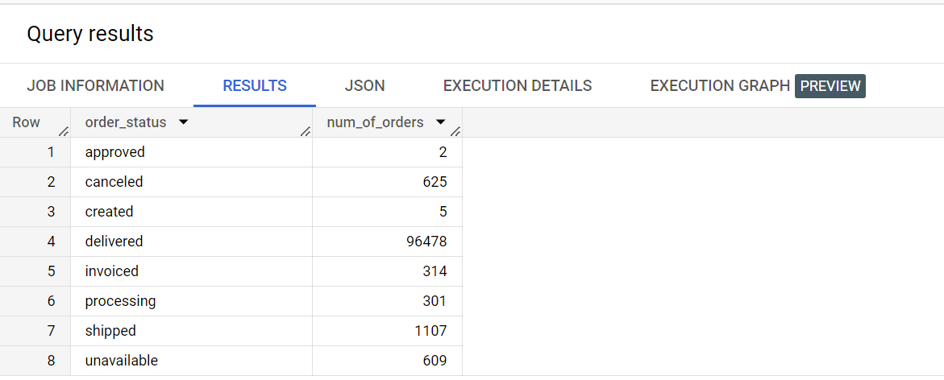

*We see that we have different number of orders based on their order status. It is found when the date in order_dataset is ordered by order status. Only orders with status as delivered, shipped and some orders which were cancelled after the product was shipped have an actual date value* ***order_deliver_carrier_date*** *populated for them in the table. Rest all orders have NULL. This means only the above mentioned orders have freight value populated for them. Hence in the below query while calculating freight value we have filtered the status condition to meet this requirement****.***

1. **Calculate days between purchasing, delivering and estimated delivery**

***SELECT***

***order_status,***

***order_purchase_timestamp,***

***order_estimated_delivery_date,***

***DATE_DIFF(order_estimated_delivery_date,order_purchase_timestamp, DAY) as est_del_time,***

***order_delivered_customer_date,***

***DATE_DIFF(order_delivered_customer_date,order_purchase_timestamp, DAY) as act_del_time,***

***DATE_DIFF(order_estimated_delivery_date, order_delivered_customer_date, DAY) as order_delayed_by***

***FROM `Assignment.orders_dataset`***

***WHERE order_status IN ("delivered", "shipped", "cancelled") AND order_delivered_carrier_date IS NOT NULL***

***ORDER BY order_purchase_timestamp***

***LIMIT 10***

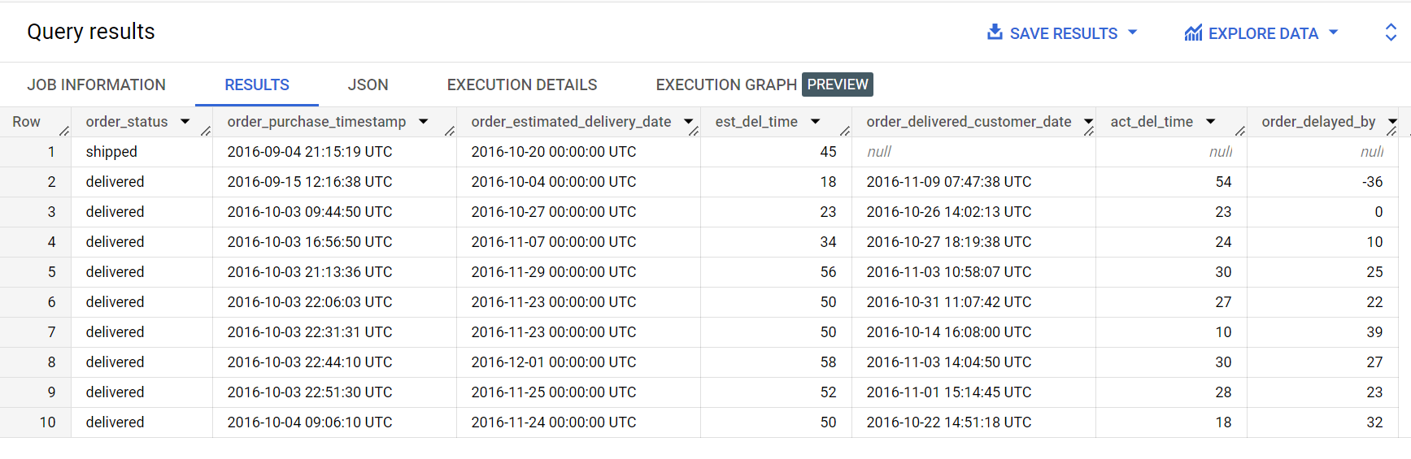

1. Find time_to_delivery & diff_estimated_delivery. Formula for the same given below:
   * time_to_delivery = order_delivered_customer_date-order_purchase_timestamp
   * diff_estimated_delivery = order_estimated_delivery_date-order_delivered_customer_date
2. **Group data by state, take mean of freight_value, time_to_delivery, diff_estimated_delivery.**

***SELECT***

***c.customer_state,***

***ROUND(AVG(DATE_DIFF(order_estimated_delivery_date,order_purchase_timestamp, DAY)),2) as time_to_delivery,***

***ROUND(AVG(DATE_DIFF(order_estimated_delivery_date,order_delivered_customer_date, DAY)),2) as diff_estimated_delivery,***

***ROUND(AVG(oi.freight_value),2) as avg_freight_value***

***FROM `Assignment.orders_dataset` as o***

***INNER JOIN `Assignment.order_items_dataset` as oi***

***ON o.order_id = oi.order_id***

***INNER JOIN `Assignment.customers_dataset` as c***

***ON o.customer_id = c.customer_id***

***WHERE order_status IN ("delivered", "shipped", "cancelled") AND order_delivered_carrier_date IS NOT NULL***

***GROUP BY c.customer_state***

***ORDER BY avg_freight_value***

***LIMIT 10***

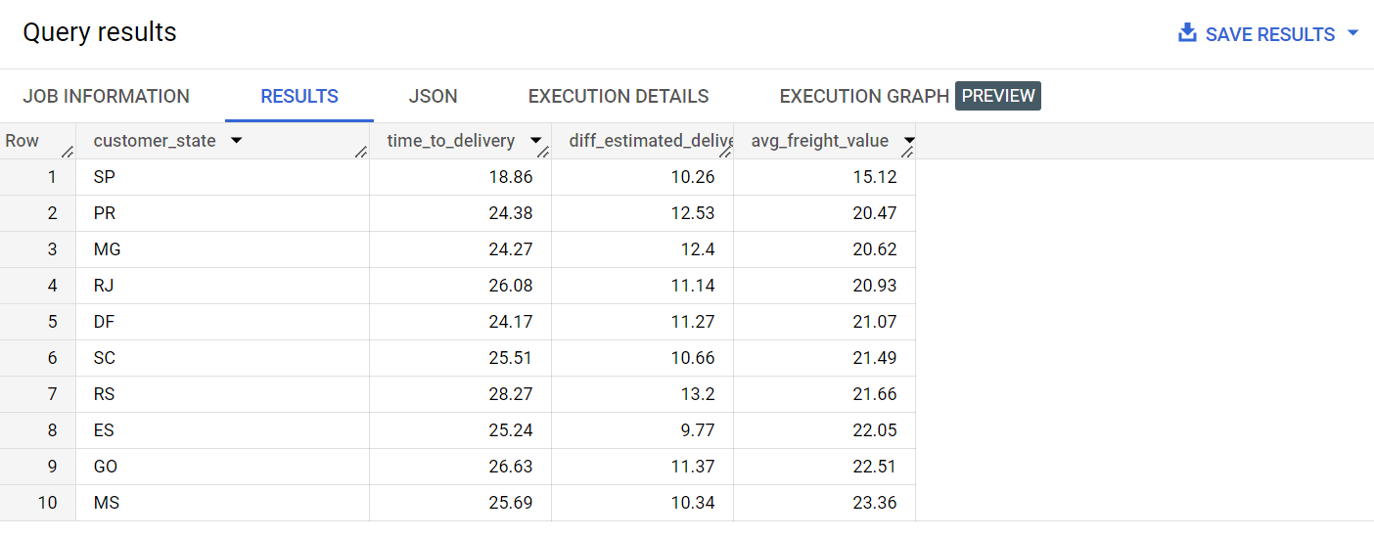

1. Sort the data to get the following:
2. Top 5 states with highest/lowest average freight value - sort in desc/asc limit 5

***Same query as above except ORDER BY avg_freight_value DESC in last second line and LIMIT 5 after that.***

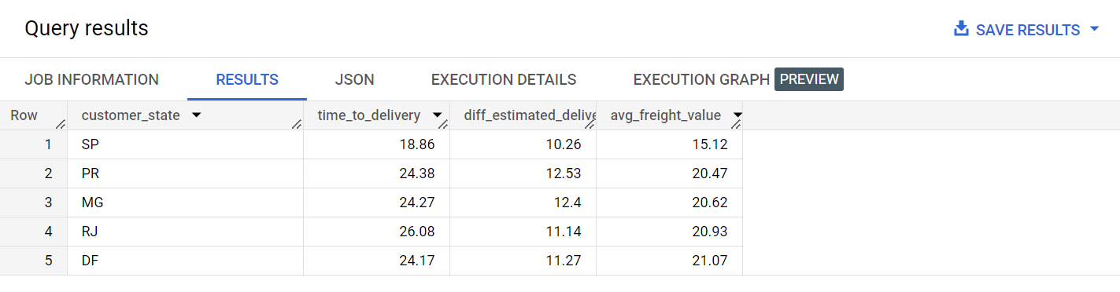

***Same query as above except ORDER BY avg_freight_value DESC in last second line and LIMIT 5 after that.***

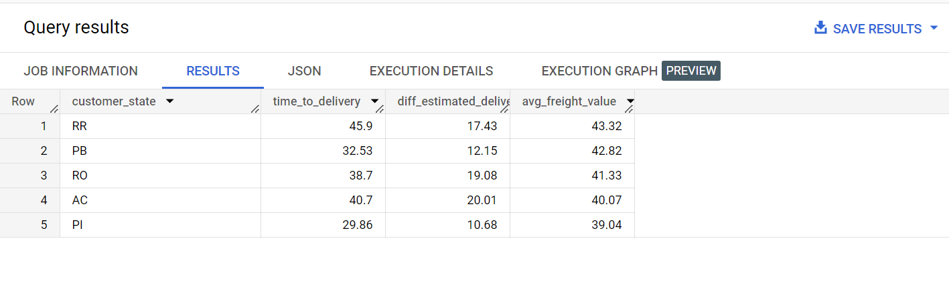

1. **Top 5 states with highest/lowest average time to delivery**

***SELECT***

***c.customer_state,***

***ROUND(AVG(DATE_DIFF(order_estimated_delivery_date,order_purchase_timestamp, DAY)),2) as avg_time_to_delivery,***

***ROUND(AVG(DATE_DIFF(order_estimated_delivery_date,order_delivered_customer_date, DAY)),2) as avg_diff_estimated_delivery,***

***ROUND(AVG(oi.freight_value),2) as avg_freight_value***

***FROM `Assignment.orders_dataset` as o***

***INNER JOIN `Assignment.order_items_dataset` as oi***

***ON o.order_id = oi.order_id***

***INNER JOIN `Assignment.customers_dataset` as c***

***ON o.customer_id = c.customer_id***

***WHERE order_status IN ("delivered", "shipped", "cancelled") AND order_delivered_carrier_date IS NOT NULL***

***GROUP BY c.customer_state***

***ORDER BY avg_time_to_delivery***

***LIMIT 5***

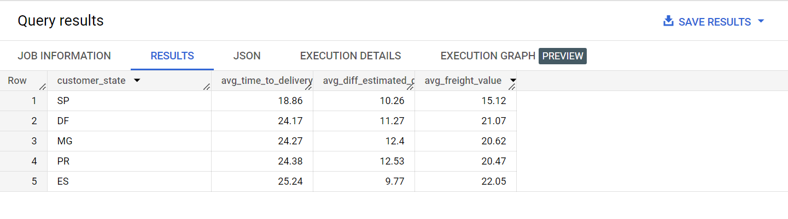

***Highest time to delivery. Same query as above, except ORDER BY avg_time_to_delivery***

***DESC in last second line.***

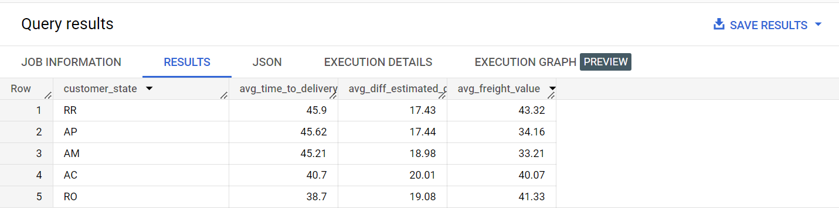

1. **Top 5 states where delivery is really fast/ not so fast compared to estimated date**

***SELECT***

***c.customer_state,***

***ROUND(AVG(DATE_DIFF(order_estimated_delivery_date,order_purchase_timestamp, DAY)),2) as avg_time_to_delivery,***

***ROUND(AVG(DATE_DIFF(order_estimated_delivery_date,order_delivered_customer_date, DAY)),2) as avg_diff_estimated_delivery,***

***ROUND(AVG(oi.freight_value),2) as avg_freight_value***

***FROM `Assignment.orders_dataset` as o***

***INNER JOIN `Assignment.order_items_dataset` as oi***

***ON o.order_id = oi.order_id***

***INNER JOIN `Assignment.customers_dataset` as c***

***ON o.customer_id = c.customer_id***

***WHERE order_status IN ("delivered", "shipped", "cancelled") AND order_delivered_carrier_date IS NOT NULL***

***GROUP BY c.customer_state***

***ORDER BY avg_diff_estimated_delivery***

***LIMIT 5***

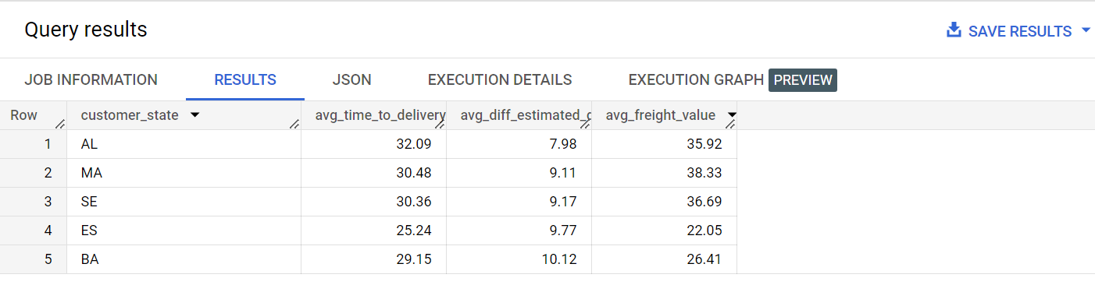

***Delivery not so fast : -***

***Same query except ORDER BY avg_diff_estimated_deliveryDESC in last second line.***

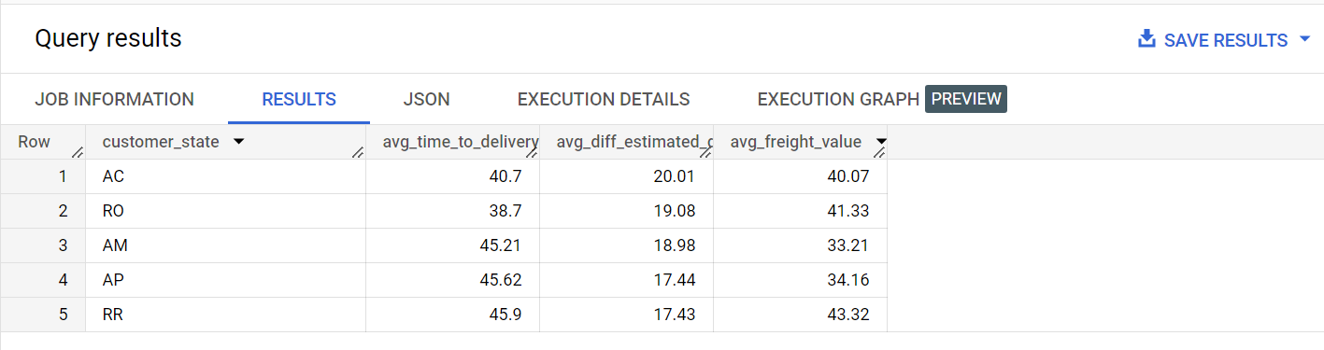

**6**. **Payment type analysis:**

1. Month over Month count of orders for different payment types

***SELECT*,***

***LAG(d.num_orders,1) OVER (PARTITION BY d.payment_type ORDER BY d.payment_type,d.Month) as previous_month_orders,***

***LEAD(d.num_orders,1) OVER (PARTITION BY d.payment_type ORDER BY d.payment_type,d.Month) as next_month_orders***

***FROM***

***(***

***SELECT***

***payment_type,***

***EXTRACT(MONTH FROM o.order_purchase_timestamp) as Month,***

***COUNT(o.order_id) as num_orders***

***FROM `Assignment.payments_dataset` as p***

***JOIN `Assignment.orders_dataset` as o***

***ON o.order_id = p.order_id***

***GROUP BY payment_type, Month***

***ORDER BY payment_type, Month***

***) as d***

***ORDER by d.payment_type, d.Month***

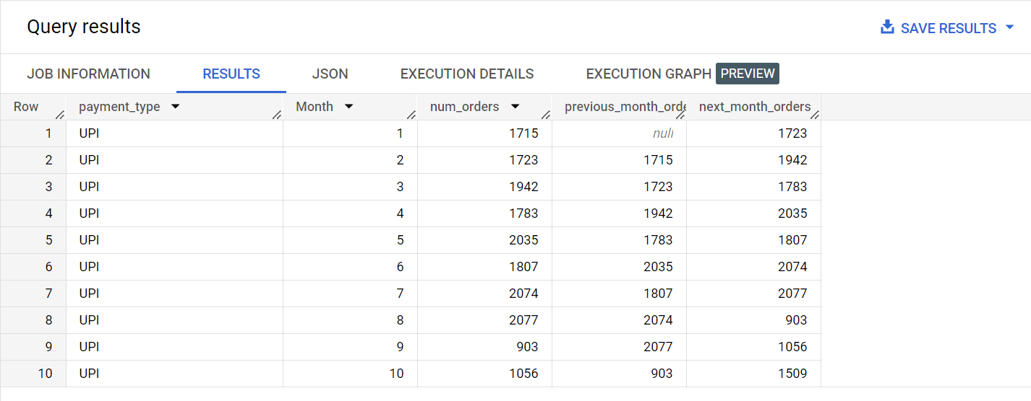

1. Count of orders based on the no. of payment instalments.

***SELECT***

***payment_installments,***

***COUNT(o.order_id) as num_orders***

***FROM `Assignment.payments_dataset` as p***

***JOIN `Assignment.orders_dataset` as o***

***ON o.order_id = p.order_id***

***GROUP BY payment_installments***

***ORDER BY payment_installments***

***LIMIT 10***

